DSA0228 - Computer Vision with Open CV
LAB Experiments
- Perform basic Image Handling and processing operations on the image.

- Read an image in python and Convert the given Image into Grayscale
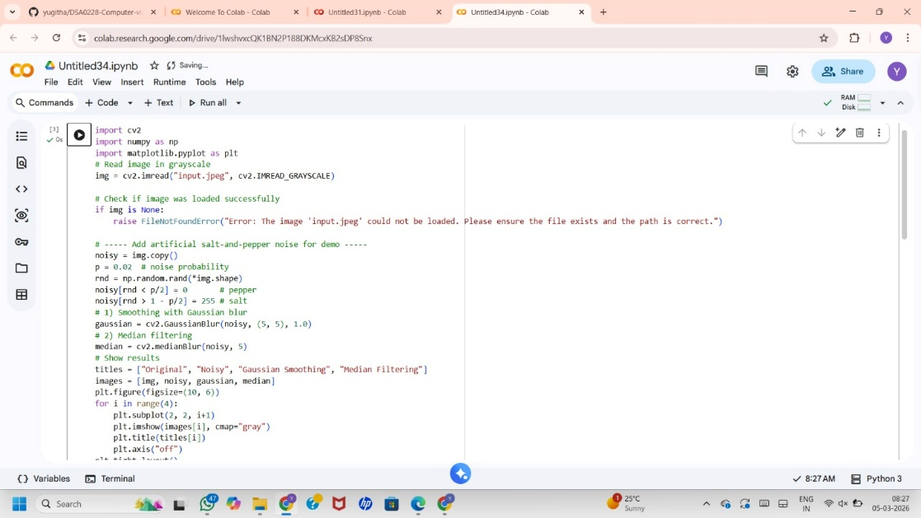

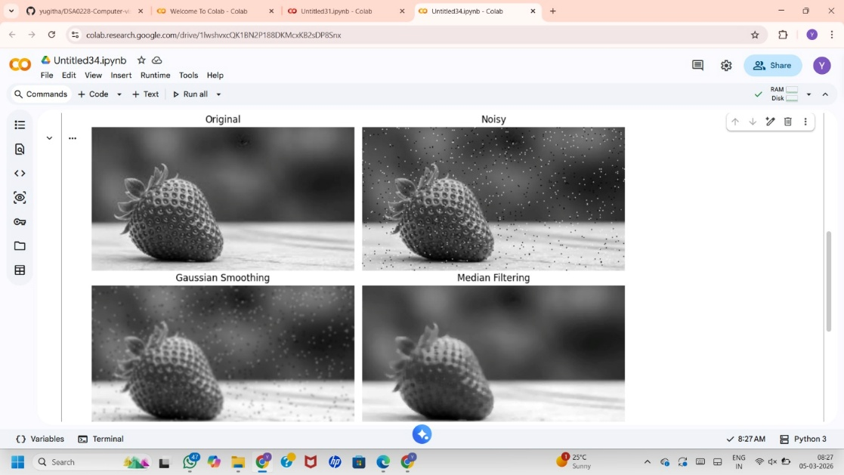

- Read an image in python and Convert an Image to Blur using GaussianBlur.

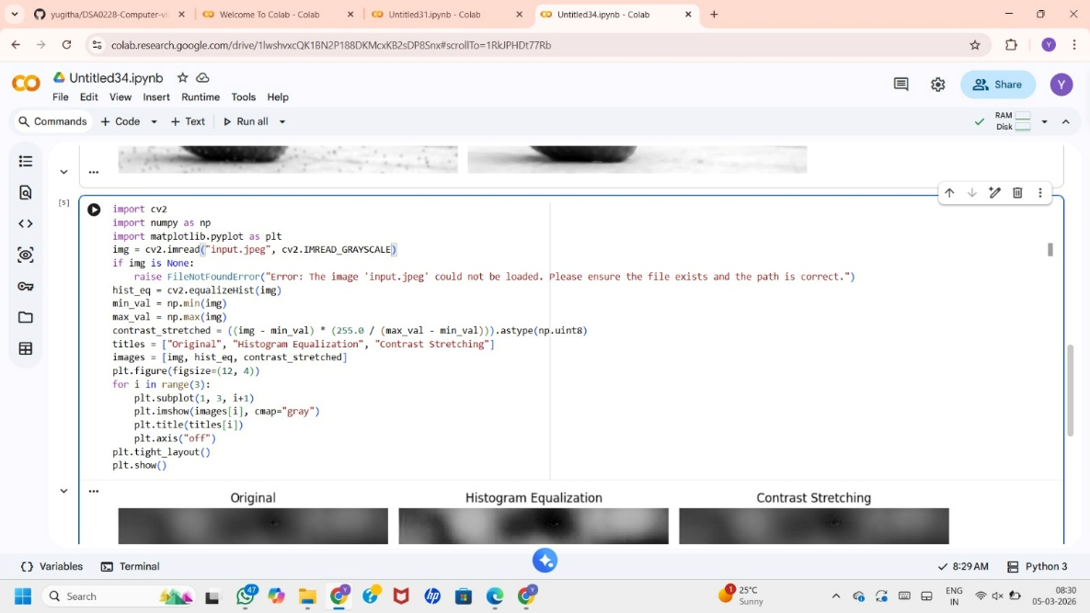

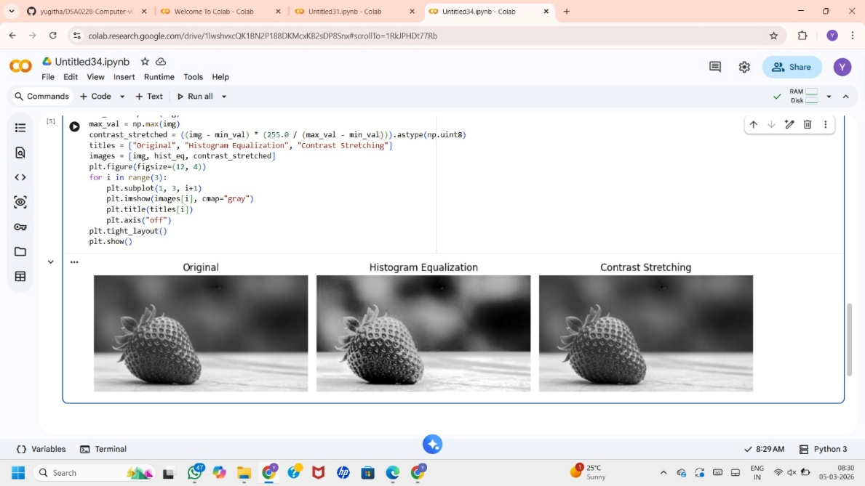

- Read an image in python and Convert the given Image to show outline using Canny function.
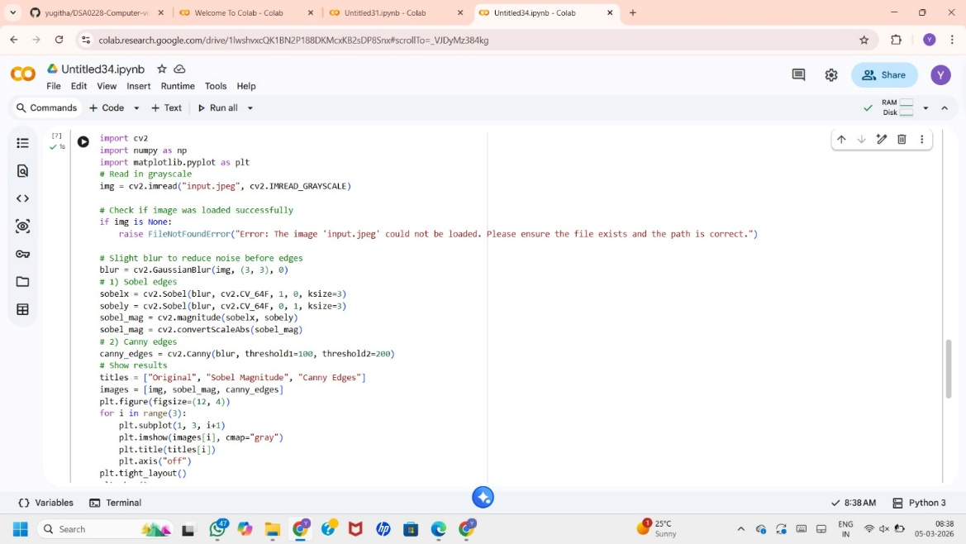

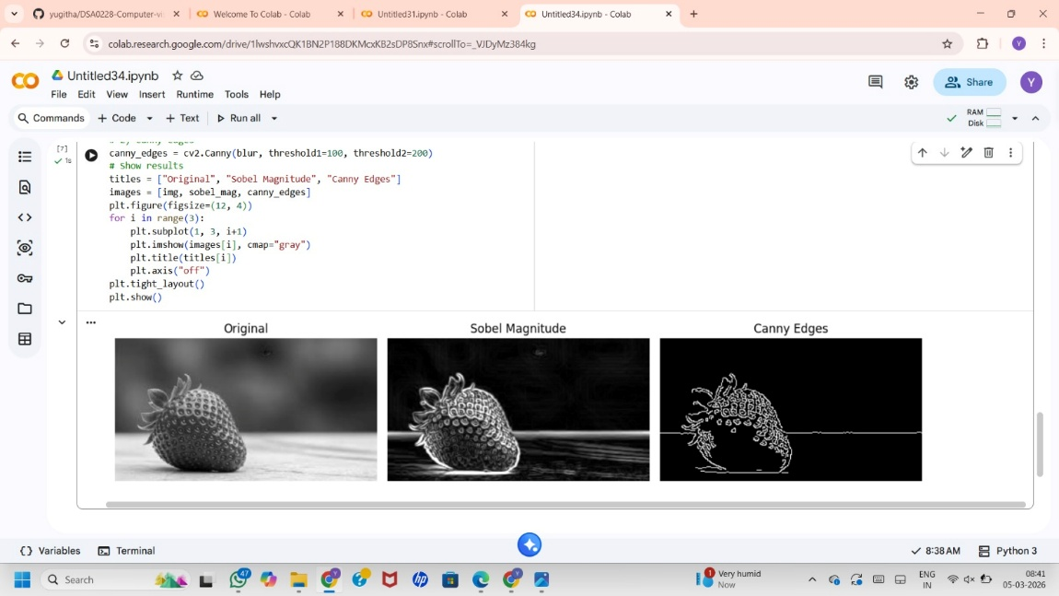

- Read an image in python and Dilate an Image using Dilate function.
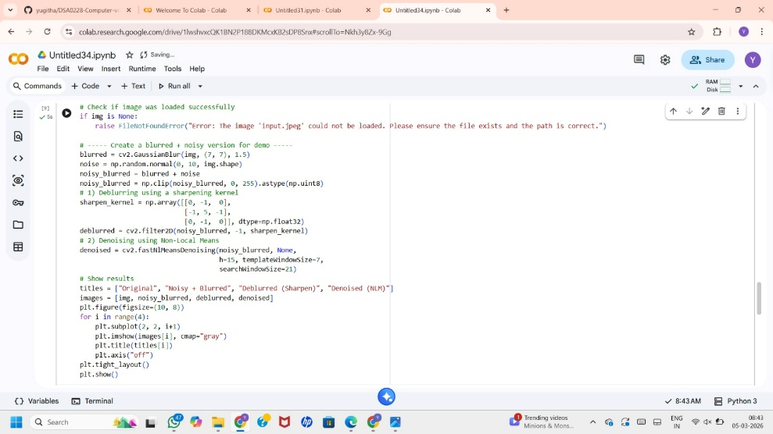

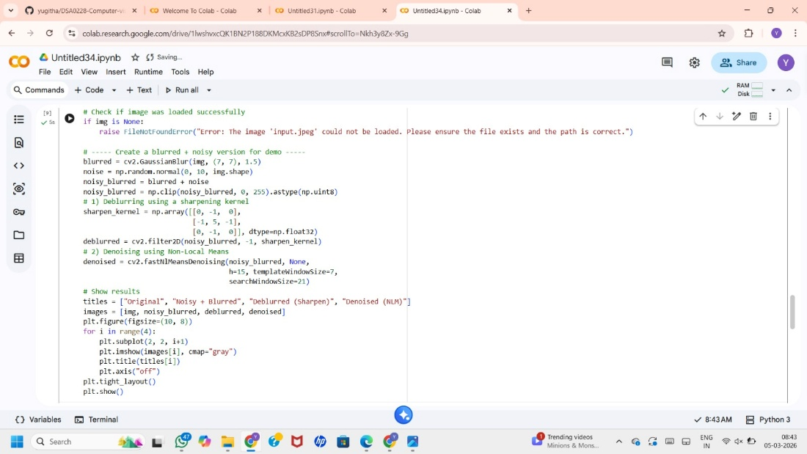

- Read an image in python and Erode an Image using erode function.

